**Test Plan: Bisection Method Calculation of Polynomial Roots**

**By: Harman Brar**

**Completed Feb 19/2021**

1. **User entered coefficient(coef4 to coef0) value out of range**

Please enter the value of the coefficient for the order 4 term

(-50.0 <= coefficient <= 50.0): -50.5

ERROR: The value of the order 4 term is out of range

Please re-enter the value of the coefficient for the order 4 term

(-50.0 <= coefficient <= 50.0): 45

Please enter the value of the coefficient for the order 3 term

(-50.0 <= coefficient <= 50.0):

1. **User entered coefficient(coef4 to coef0) value out of range 4 times(max amount)**

Please enter the value of the coefficient for the order 4 term

(-50.0 <= coefficient <= 50.0): -60

ERROR: The value of the order 4 term is out of range

Please re-enter the value of the coefficient for the order 4 term

(-50.0 <= coefficient <= 50.0): -60.5

ERROR: The value of the order 4 term is out of range

Please re-enter the value of the coefficient for the order 4 term

(-50.0 <= coefficient <= 50.0): 50.5

ERROR: The value of the order 4 term is out of range

Please re-enter the value of the coefficient for the order 4 term

(-50.0 <= coefficient <= 50.0): 500

ERROR: The value of the order 4 term is out of range

Maximum number of tries entering data exceeded. Program terminating.

1. **User entered incorrect range for minimum x value**

Please enter the minimum X value in the initial range

(-60.0 <= minimum X value in the initial range <= 60.0): -60.1

ERROR: The minimum X value in the initial range is out of range

Please re-enter the minimum X value in the initial range

(-60.0 <= minimum X value in the initial range <= 60.0):

1. **User entered incorrect range for minimum x value 4 times(max amount)**

Please enter the minimum X value in the initial range

(-60.0 <= minimum X value in the initial range <= 60.0): -60.1

ERROR: The minimum X value in the initial range is out of range

Please re-enter the minimum X value in the initial range

(-60.0 <= minimum X value in the initial range <= 60.0): 70.0

ERROR: The minimum X value in the initial range is out of range

Please re-enter the minimum X value in the initial range

(-60.0 <= minimum X value in the initial range <= 60.0): -700

ERROR: The minimum X value in the initial range is out of range

Please re-enter the minimum X value in the initial range

(-60.0 <= minimum X value in the initial range <= 60.0): -90

ERROR: minimum X value in the initial range is out of range

Maximum number of tries entering data exceeded. Program terminating.

1. **User entered incorrect range for maximum x value**

Please enter the maximum X value in the initial range

(-60.0 <= maximum X value in the initial range <= 60.0): 70.4

ERROR: The maximum X value in the initial range is out of range

Please re-enter the maximum X value in the initial range

(-60.0 <= maximum X value in the initial range <= 60.0):

1. **User entered incorrect range for maximum x value 4 times(max amount)**

Please enter the maximum X value in the initial range

(-60.0 <= maximum X value in the initial range <= 60.0): 70.4

ERROR: The maximum X value in the initial range is out of range

Please re-enter the maximum X value in the initial range

(-60.0 <= maximum X value in the initial range <= 60.0): 90.2

ERROR: The maximum X value in the initial range is out of range

Please re-enter the maximum X value in the initial range

(-60.0 <= maximum X value in the initial range <= 60.0): 60.4

ERROR: The maximum X value in the initial range is out of range

Please re-enter the maximum X value in the initial range

(-60.0 <= maximum X value in the initial range <= 60.0): 333.5

ERROR: maximum X value in the initial range is out of range

Maximum number of tries entering data exceeded. Program terminating.

1. **User entered incorrect range for rows**

Please enter the number of rows in the table

(1 <= number of rows in the table <= 25): 33

ERROR: The number of rows in the table is out of range

Please re-enter the number of rows in the table

(1 <= number of rows in the table <= 25):

1. **User entered incorrect range for rows 4 times(max amount)**

Please enter the number of rows in the table

(1 <= number of rows in the table <= 25): 33

ERROR: The number of rows in the table is out of range

Please re-enter the number of rows in the table

(1 <= number of rows in the table <= 25): 333

ERROR: The number of rows in the table is out of range

Please re-enter the number of rows in the table

(1 <= number of rows in the table <= 25): -1

ERROR: The number of rows in the table is out of range

Please re-enter the number of rows in the table

(1 <= number of rows in the table <= 25): 100

ERROR: the number of rows in the table is out of range

Maximum number of tries entering data exceeded. Program terminating.

1. **User entered incorrect range for interval shift**

Please enter the shift of the starting interval between rows

(0.0 <= shift of starting interval between rows <= 20.0): 200

ERROR: The shift in the starting interval between rows is out of range

Please re-enter the shift in the starting interval between rows

(0.0 <= shift of starting interval between rows <= 20.0):

1. **User entered incorrect range for interval shift 4 times(max amount)**

Please enter the shift of the starting interval between rows

(0.0 <= shift of starting interval between rows <= 20.0): 200

ERROR: The shift in the starting interval between rows is out of range

Please re-enter the shift in the starting interval between rows

(0.0 <= shift of starting interval between rows <= 20.0): 20.4

ERROR: The shift in the starting interval between rows is out of range

Please re-enter the shift in the starting interval between rows

(0.0 <= shift of starting interval between rows <= 20.0): -1.0

ERROR: The shift in the starting interval between rows is out of range

Please re-enter the shift in the starting interval between rows

(0.0 <= shift of starting interval between rows <= 20.0): 2000

ERROR: the shift in the starting interval between rows is out of range

Maximum number of tries entering data exceeded. Program terminating.

1. **User entered a file name that fails to open**

Enter the name of the output file *\?

ERROR: the file did not open, please re-enter the name of the output file:

1. **User entered a file name that failed to open 4 times(max amount)**

Enter the name of the output file *\?

ERROR: the file did not open, please re-enter the name of the output file: *hello.txt

ERROR: the file did not open, please re-enter the name of the output file: **bla?bla.txt

ERROR: the file did not open, please re-enter the name of the output file: ??**hello\.txt

ERROR: the file did not open

Maximum number of tries entering data exceeded. Program terminating.

1. **User entered all input correctly, maximum iterations set to 50(see output file attached for results)**

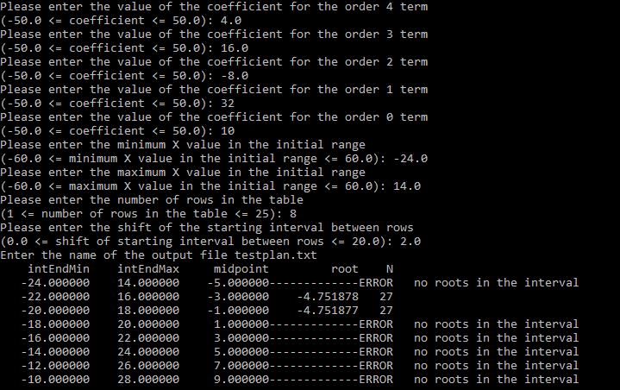

**14. User entered all input correctly, maximum iterations set to 12(see output file attached for results)**

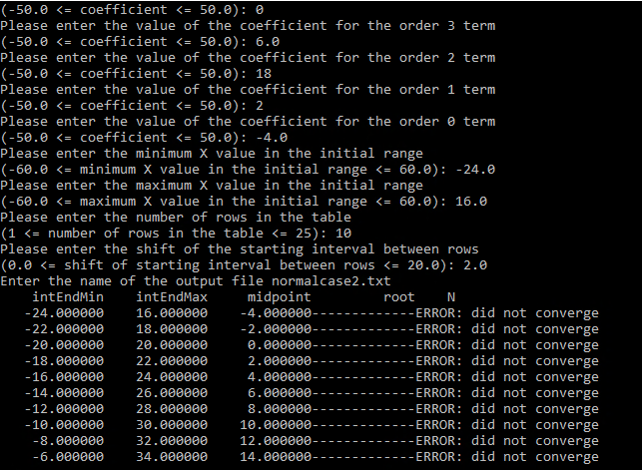

**Output File 1: Normal Case 1**

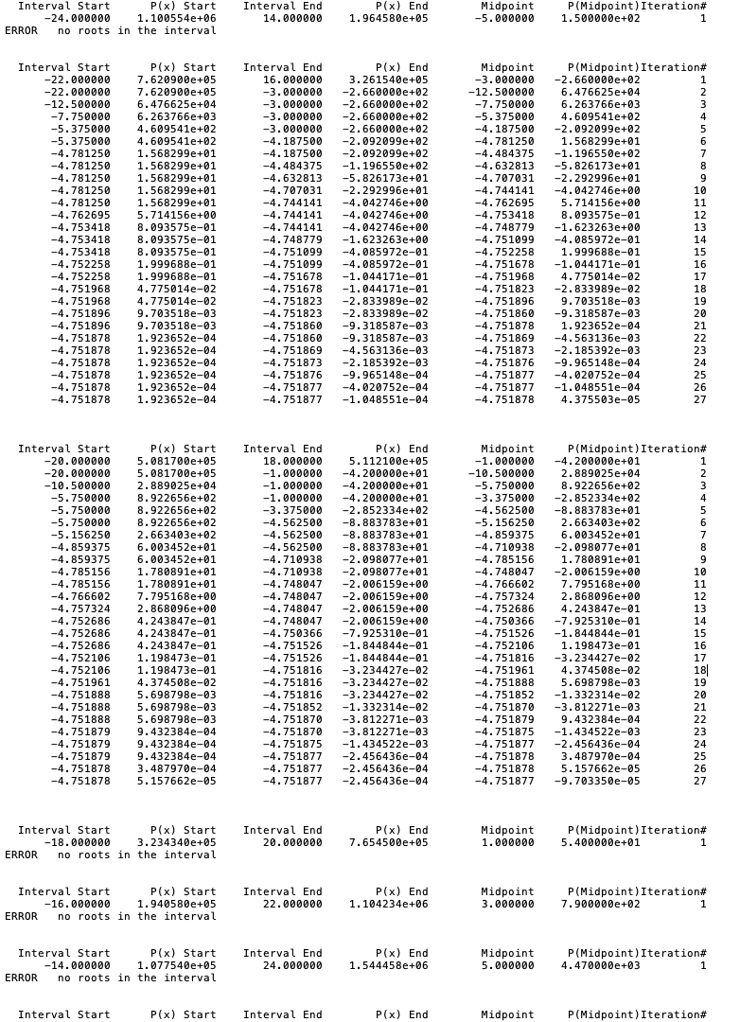

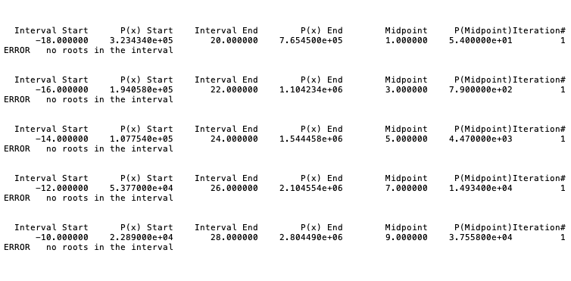

**Output File 2: Normal Case 2**

